National University of Computer and Emerging Sciences



Laboratory Manual

for

Computer Organization and Assembly Language Lab

(EL 229)

|  |  |
| --- | --- |
| Course Instructor | Ms. Tazeem Haider |
| Lab Instructor(s) | Mr. Gullsher Ali Chaudhary  Ms. Nimra Abbas |
| Section | CS-3L |
| Semester | Fall 2022 |

Department of Computer Science

FAST-NU, Lahore, Pakista

**Question 1**

Write an assembly subroutine the will copy the first half of display memory to second half. For example. Your output after executing the code should be following.

Before executing:

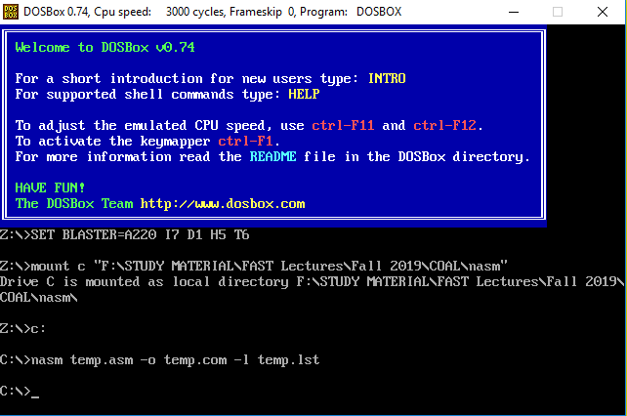

After Executing

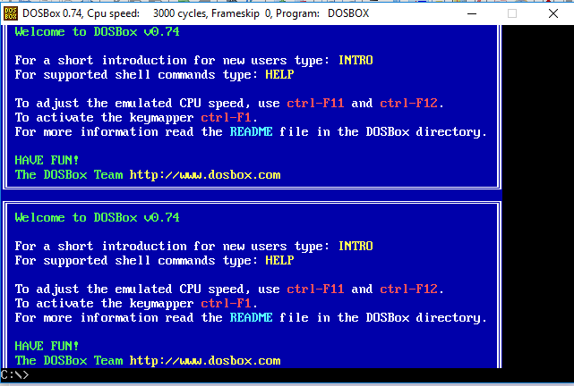

**Question 2**

Write a subroutine that take string and its length as input and print the string without spaces. Note that the original string should not be changed anywhere in your code.

Example:

If string is “I am From Pakistan”, it should be displayed on screen as “IamFromPakistan”.

**Question 3**

Write code to find the byte in AL in whole megabyte of memory such that each memory location is compared to AL only once.